Project Report
On
Pet store website

Submitted by
Richa Padhariya
Jenil Shyara
Of
Python technology
In
Tops career center

December 2021

ACKNOWLEDGEMENT
Towards the successful completion of my python programme, I feel greatly obliged to certain Specials. I am sincerely gratitude to Pranjal Koshti, Tops carrer center, who providing me this opportunity and necessary support during the development of the project.
- Richa Padhariya, Jenil Shyara

ABSTRACT
This web application allows to buy products for pets like food, accessories pet breeds, and also it allows to view different Veterinarians. So, anyone can book appointment for their pets at any time.
People can also upload pictures of their pets, and other people can view photos and like photos.
There are mainly 4 entities: Customer, Retailers, Doctors, Admin.
All entities can access their respective role in website, e.g. customer can buy products, retailers can add products, doctor can view appointments, and admin can manage doctors, retailers, orders, etc.

ABBREVIATION
Abbreviations used throughout this whole document for Survey Application are:
HTML: Hypertext Markup Language
PIP: Preferred Installer Program
CSS: Cascading Style Sheet
JS: JavaScript
URL: Uniform Resource Locator
ER: Entity Relation
DFD: Data Flow Diagram
API: Application Programing Interface
DBMS: Database Management System
SQL lite: Structured Query Language

chapter 1: intoduction

pROJECT SUMMERY:
The basic concept of this PATOI system, we create global web-based application in Django with Python language for online store. We provide platform to buy and sell products . Each user can access the website via registration and login. User can also edit their profile. Admin can manage the doctors and retailers and orders also. Customer can view products and also can add any product to cart and Wishlist. Customers can view different doctors and book appointment with them according to their own time. Doctors have option for approve or denial for the appointment.
Features
Customer:
- Customer can register by name, email, contact no and password, they can also edit their residential address, region, pin code, country into their profile.
- After registration customer can login via email address and password.
- Customer can search product by category wise also and they can view products and can add to cart and Wishlist also. After adding into the cart customer can make payment and place the order. Customer can view order history also.
- Customer can view profile of any doctor and book appointment with them for their pet.
- Customer can upload photos of their pets, also view photos of other people’s photos and can like it too.
- Customer can give feedbacks for the products and website also.

Retailer:
- Retailer can register themselves. And can login via email and password.
- Retailer can add their products, upload picture of their product, add description and other details.
- Retailer can view customer details for the order delivery.
- Retailer will receive his payment after product delivered to the customer. Retailer can view history of receives payments and orders.
- Retailer can edit their profile and add description for their shop.
- Retailer can use forget password feature also.

Doctor:
- Doctor can registration via email, password, username, contact number, etc. Doctor can login via email and password.
- Doctor can edit their profile and description.
- Doctor can view appointments and can manage it.
- Doctor can use forget password features.

Admin:
- Admin can directly login via email and password.
- Admin can view all doctors, customers and retailers. Admin can add or remove retailers or doctors. Admin can manage orders and view all product.
- Admin can view feedbacks given by customers. Admin can view photos uploaded by customers.
- Admin can logout also.

pROJECT purpose:
Now a days there are many pet products website available on the internet, but it is very rare that people can buy product, also view doctors and can also book appointment with the doctor in a same website. Therefore, this Patoi website is designed.
Therefore, using new concept, people can use all above thing in one website. According to now a busy day, it is best to buy products and also meeting with doctor in only one website.
Therefore, our main purpose or the primary goal of this project is to provide publicly available, data describing the intersection between doctors, retailers and customers.

PROJECT SCOPE
The scope of this project can be enhanced further by adding many facilities for the customers, doctors and retailers. The software is flexible enough to be modified and implemented as per future requirements. We have tried our best to pre- sent this free and user– friendly website. Message and Email alerts for new products and offers availability can be added to the system so that users do not miss the updates. User can able to chat like what's app groups for better user experience are passed on as a future scope to work upon.

TECHNOLOGY AND TOOLS
The development of the application is planned using the open-source environment to increase its usability. All routines developed using the language Python, framework Django and operating system Window. Below is a brief description of the language Python, Window operating system, Django and Visual Studio Code used for writing codes.
FRONT- END TECHNOLOGY
- HTML: Hypertext Markup Language is the code that is used to structure a web page and its content.
- CSS: CSS is the language for describing the presentation of Web pages, including colors, layout, and fonts.
- Bootstrap: Bootstrap is a potent front-end framework used to create modern websites and web apps.
- JavaScript: JavaScript is a text-based programming language used on both the client side and server-side that allows you to make web pages interactive.

BACK- END TECHNOLOGY
- Django: Django is a high-level Python web framework that enables rapid development of secure and maintainable websites.
- Languages used: Python Python is an interpreted high-level general-purpose programming language. Python's design philosophy emphasizes code readability with its notable use of significant indentation.
- Database : sql lite
MySQL is a relational database management system based on SQL – Structured Query Language. The most common use for MySQL however, is for the purpose of a web database.
SQLite – Django built-in database
- Software genre: Web framework

TOOLS USED
- Visual Studio Code: Visual Studio Code is a lightweight but powerful source code editor, which runs on your desktop and is available for Windows, macOS and Linux. It comes with built-in support for JavaScript, Typescript and Node.js and has a rich ecosystem of extensions for other languages (such as C++, C#, Java, Python, PHP, Go) and runtimes (such as .NET and Unity).
- Command Prompt: cmd.exe is the default command-line interpreter for the OS/2, eComStation, ArcaOS, Microsoft Windows, and ReactOS operating systems. The name refers to its executable filename. It is also commonly referred to as cmd or the Command Prompt, referring to the default window title on Windows.

chapter 2: litrature survey
This is a study of research paper for multipurpose web based application related to notification, event, games, maintenance, member details etc. system. The idea behind these papers is to study various methods and techniques to push notification on various android devices. There are many handful technologies, which push data or content on mobile devices. The need of technologies studied are Google Cloud Messaging, C2DM (Cloud to Device Messaging) and Xtify is for authenticating a user, as well as handling all aspects of messages and delivery to the target application on the target device. The basic notification application is implemented using Google Cloud messaging. Google Cloud Messaging for web (GCM) provides a facility to send data from server to Android mobile device of user, and also receives messages from other devices within a network according to developer website, “a service that helps developers sends data from servers to their web applications on Android devices.” Hence, the overall purpose and scope of this project is reachable by Push notification technology. In order to curb the old practices of maintaining the records of bills, funds, other services, meeting details etc digitalization of the housing societies is very important. Social networks play an important role at connecting the people via online chatting, participating in online campaigns and clubs. Thus, we have introduced the groups system every housing society has various groups for its purposes like social work, business advertisement. The web application makes use of recommendation system which suggests the groups (if the group is available in the society) to a particular person based on its likings. The resident can thus join and leave the group whenever required. Therefor the purpose of this web-based application is to provide relevant and peaceful environment.
Why survey?
The purpose of a literature review is to gain an understanding of the existing research and database relevant to a particular topic or area of study, and to present that knowledge in the form of a written report. Conducting a literature review helps you build your knowledge in your field.

CHAPTER 3: PROJECT MANAGEMENT
Project planning:
- The problem is decomposed into smaller problems, software managers use historical data (as well as personal experience and intuition) to determine estimates for each.
- Project planning is a method for stating how to complete a project within a certain period of time, usually with defined stages, and with designated resources.
- It begins by setting the scope of a project and eventually working through each level of dependent actions, tasks, checkpoints and deadlines.
- The final estimates are typically adjusted by taking project complexity and risk into account.
- The resulting work product is called project management plan.
- Project planning involves estimating how much time, efforts, money, and resources will be required build a specific software system. So that project outcome can be bounded.
- The objective of the software planning is providing the framework the enables the manager to make reasonable estimation of the resources, cost and schedule.
Project planning involves estimating how much time, efforts, money, and resources will be required build a specific software system. So that project outcome can be bounded.
Project scheduling:
- Software project scheduling is an activity that distributes estimated efforts across the planned duration by allocating the effort to specific software engineering tasks.
- Proper Scheduling Requires:
- All tasks appear in network.
- Effort and timing are intelligently allocated to each task.
- Interdependencies between tasks are properly indicated.
- Resources are allocated for the work to be done.
Project development approach:
Requirement Analysis: In this stage various requirement of all two, Admin, User. Admin expects easy operation with the system, Faster and Efficient management of Product and User data, time-saving. Users requires quick and on-time Delivery of Products. Admin expects error free data of users that have registered for Website.
Design: In this phase, various calculations were done regarding how the campus recruitment system will be made and how it will work or operate with particular hardware, software, and network infrastructure. In order to achieve the desired system, design phase has been executed using two different parts: Logical Design in which role and functionalities of all users interacting with system were identified and Database Design in which structure of database was designed to provide fast data accessibility
Implementation: Based on the results of Requirement Analysis and Design phases, selection of appropriate technology was done and to achieve the planned system, actual coding was done in the Implementation Phase. In this phase, various software and installation files were downloaded to work with technologies such as Django and Bootstrap. The task of designing the database and creating methods to store, update and retrieve the data from it was also done in this phase.
Testing: As the name of the phase suggests, the task of testing the fully functioning system was done in this phase. It included many steps such as accessing all its pages on multiple devices with different resolution or screen sizes to test its Responsiveness. It also includes testing all the possible ways of storing, updating and retrieving the data from the database.
Maintenance: In this stage, the well-functioning system is being looked after if it needs any changes in its design or database planning. Such changes are usually required at certain intervals of time to ensure that the system works properly without causing any errors or data losses.

CHAPTER 4: SYSTEM REQUIREMENT
User characteristics:
There are essentially four types of users for PATOI system, first one is the Customer. Who will come to this portal to choose many functionalities to view and buy all content. Second, one is the retailer who is allowed to add products. Third, one is doctors, who is allowed to add his profile and view appointments. Last and most import user is administrator who is allowed to control all activities by the functions like manage all retailers and doctor and orders.
- Customers: Login, Registration, forget password, edit profile, search product, search product by category, buy products, add to cart, Wishlist, payments, upload photos, like photos, view photos, view doctor details, book appointment, order history, product feedback, website feedback, logout.
- Retailers: add product, add product details, view order details, customer details, payment history, receive payments, order history, edit profile, view all product, login, registration, forgot password, logout.
- Doctors: login, registration, view appointment, appointment manage, edit profile, add description, forget password, logout.
- Admin: login, view all doctors, view all customers, view all retailers, manage retailers, manage doctors, manage orders, view product feedback, view website product, view photos, forget password, logout.

FUNCTIONAL REQUIREMENT:
Functional requirements may involve calculations, technical details, data manipulation and processing and other specific functionality that define what a system is supposed to accomplish. Function requirement means the main requirement that should be satisfied via this project, so the following are the Functional requirement of this system.
- Effective system.
- Maintaining the databases.
- It should maintain user characteristics.

NON-FUNCTIONAL REQUIREMENT:
This software should perform the same way irrespective to its operating System environments. Time taken for importing files and publishing the multimedia presentation should be minimum.
- Safety Requirements: This requirement does not apply for our software as this is cannot pose a threat in no way.
- Security Requirements: As all the operations are to be done within a single system, security is not an issue for this software.
- Quality Requirements: Quality has a number of attributes some of the important attributes for this software are:
  - Portability: As this software is to work on multiple platforms, portability is an essential attribute and we ensure this by using PHP as our programming language.
  - Test-ability: As a basic characteristic, the software needs to be testable to ensure correctness.
- User Interfaces: To make this system useful for maximum reach of user we have create very user-friendly interfaces so that any kind of user with very less skill of computer can use this system.
- Authentication:
- Authorization:

CHAPTER 5: DATA DICTIONARY
Data Dictionary is the data about the data. It is also termed as meta data, which gives the data about the data stored in the databases. It defines each data term encountered during the analysis and design of the new system. Data elements can describe files or the processes.
Following are some rules that define the construction of data dictionary entries:
• Words should be defined to understand for what they need and not the variable need by which they may be described in the program.
• Each word must be unique. We cannot have two definitions of the same client.
• Aliases or synonyms are allowed when two or more entries show the same meaning. For example, a vendor may also be called as customer number.
• A self-defining word should not be decomposed. It means that reduction in any information in to sub part should be done only if it is required, that is it is not easy to understand directly.
• Data dictionary includes information such as the number of records in the file, the frequency of the processes that will run security factor like password, which must be entered to get access of the information.

USERS INFORMATION TABLE
Table Name: User
Primary Key: uid

Field Name | Data Type | Constrain | Description
uid | int | Primary key | Id of User
email | varchar | Not null, Unique | Email of User
password | varchar | Not null | Password of User
otp | int | Not null | Store OTP
role | varchar | Not null | Role of User

Customer detail table:
Table Name: Customer Details

Primary Key: cid

Field Name | Data Type | Constrain | Description
First name | varchar | Not Null | First name of customer
Last name | varchar | Not Null | Last name of customer
Email | varchar | Not Null, unique | Email of customer
Address | varchar | Null | Address of customer
Contact number | int | Not Null | Contact number of customer
Pin code | int | Null | Pin code
Country | Varchar | Null | Country of customer
City | varchar | Null | City of customer

Doctor detail table:
Table Name: Doctor Details

Primary Key: did

Field Name | Data Type | Constrain | Description
First name | Varchar | Not Null | First name of doctor
Last name | varchar | Not Null | Last name of doctor
Email | varchar | Not Null, unique | Email of doctor
Address | varchar | Null | Address of doctor
Contact number | int | Not Null | Contact number of doctor
Pin code | int | Null | Pin code
Country | Varchar | Null | Country of doctor
City | varchar | Null | City of doctor

Retailer detail table:
Table Name: Retailer Details

Primary Key: rid

Field Name | Data Type | Constrain | Description
First name | Varchar | Not Null | First name of Retailer
Last name | varchar | Not Null | Last name of Retailer
Email | varchar | Not Null, unique | Email of Retailer
Address | varchar | Null | Address of Retailer
Contact number | int | Not Null | Contact number of Retailer
Pin code | int | Null | Pin code
Country | Varchar | Null | Country of Retailer
City | varchar | Null | City of Retailer

Product table:
Table Name: Product Details

Primary Key: pid foreign key: rid

Field Name | Data Type | Constrain | Description
Product name | varchar | Not Null | Name of product
rid | int | Not null | Id of retailer
Description | varchar | Not Null | Description of product
Image | img | Not Null | Email of Retailer
Quantity | int | Null | Quantity of product
category | varchar | Not null | Category of product

Cart table:
Table Name: Product Details

Primary Key: crid foreign key: pid, cid

Field Name | Data Type | Constrain | Description
pid | int | Not Null | Id of product
cid | int | Not null | Id of customer
Quantity | int | Not Null | Quantity of product
Amount | int | Not null | Total amount

Wishlist table:
Table Name: Product Details

Primary Key: wid foreign key: pid, cid

Field Name | Data Type | Constrain | Description
pid | int | Not Null | Id of product
cid | nit | Not null | Id of customer

Order table:
Table Name: Order Details

Primary Key: oid foreign key: pid, cid

Field Name | Data Type | Constrain | Description
pid | int | Not Null | Id of product
cid | int | Not null | Id of customer
date | date | Not Null | Date of order
Quantity | int | Not Null | Quantity of product
Amount | int | Not null | Total amount

Appointment table:
Table Name: Appointment Details

Primary Key: aid foreign key: cid,did

Field Name | Data Type | Constrain | Description
did | int | Not Null | Id of doctor
cid | int | Not null | Id of customer
date | date | Not Null | Date of book appointment
time | time | Not Null | Time of booking appointment
Date | Date | Not null | Date of appointment
time | Time | Not null | Time of appointment

Payment table:
Table Name: Payment Details

Primary Key: pyid foreign key: cid

Field Name | Data Type | Constrain | Description
Oid | id | Not null | Id of order
date | date | Not Null | Date of order
cid | int | Not null | Id of customer
Amount | int | Not null | Total amount

Gallery Photos table:
Table Name: Gallery Photos details

Primary Key: gphid foreign key: cid

Field Name | Data Type | Constrain | Description
cid | int | Not Null | Id of customer
Date | time | Not Null | Date of upload photo
Photo | img | Not null | Image
Likes | int | Not null | Likes on the posts

Product Feedback table:
Table Name: Product feedback details

Primary Key: fid foreign key: pid,cid

Field Name | Data Type | Constrain | Description
Pid | int | Not Null | Id of product
cid | int | Not null | Id of customer
Description | varchar | Not Null | Feedback of product

Website Feedback table:
Table Name: website feedback details

Primary Key: fid foreign key: cid

Field Name | Data Type | Constrain | Description
cid | int | Not Null | Id of customer
Description | varchar | Not Null | Feedback of product

Chapter 6: test case
Black box testing:
In black-box testing, a tester doesn't have any information about the internal working of the software system. Black box testing is a high level of testing that focuses on the behavior of the software. It involves testing from an external or end-user perspective. Black box testing can be applied to virtually every level of software testing: unit, integration, system, and acceptance.

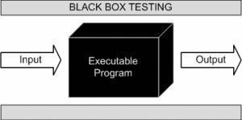

This method is named so because the software program, in the eyes of the tester, is like a black box; inside which one cannot see. This method attempts to find errors in the following categories:
    - Incorrect or missing function
    - Interface errors
    - Errors in data structures or external database access
    - Behavior or performance errors
    - Initialization and termination errors

Example: A tester, without knowledge of the internal structures of a website, tests the web pages by using a browser; providing inputs (clicks, keystrokes) and verifying the outputs against the expected outcome.

Advantages:
  - Tests are done from a user’s point of view and will help in exposing discrepancies in the specifications.
  - Tester need not know programming languages or how the software has been implemented.

Disadvantages:
  - Only a small number of possible inputs can be tested and many program paths will be left untested.
  - Without clear specifications, which are the situation in many projects, test cases will be difficult to design.
  - Tests can be redundant if the software designer/developer has already run a test case.
  - Ever wondered why a soothsayer closes the eyes when foretelling events? So is almost the case in Black Box Testing.

White box testing:
White Box Testing (also known as Clear Box Testing, Open Box Testing, Glass Box Testing, Transparent Box Testing, Code-Based Testing or Structural Testing) is a software testing method in which the tester knows the internal structure/design/implementation of the item being tested. The tester chooses inputs to exercise paths through the code and determines the appropriate outputs. Programming know-how and the implementation of knowledge is essential. White box testing is testing beyond the user interface and into the nitty-gritty of a system.

This method is named so because the software program, in the eyes of the tester, is like a white/transparent box; inside which one clearly sees.

Example: A tester, usually a developer as well, studies the implementation code of a certain field on a web page, determines all legal (valid and invalid) AND illegal inputs and verifies the outputs against the expected outcomes, which is also determined by studying the implementation code.

ADVANTAGES:
  - Testing can be commenced at an earlier stage. One need not wait for the GUI to be available.
  - Testing is more thorough, with the possibility of covering most path

DISADVANTAGES:
  - Since tests can be very complex, highly skilled resources are required, with a thorough knowledge of programming and implementation.
  - Test script maintenance can be a burden if the implementation changes too frequently.

Since this method of testing is closely tied to the application being tested, tools to cater to every kind of implementation/platform may not be readily available

Test case:

The purpose of testing is to discover errors. Testing is the process of trying to discover every conceivable fault or weakness in a work product. It provides a way to check the functionalities of components, sub-assemblies, and/or a finished product it is the process of exercising software with the intent of ensuring that the software system meets its requirements and user expectations and does not fail in an unacceptable manner. There are various types of tests. Each test type addresses a specific testing requirement.

ADMIN TEST CASE:

Tc. no | Test case Description/ Summary | Pre- condition | Test Steps | Expected Result | Actual Result | Status
1 | Admin Login | Admin has email and password | - open login form  - Enter Email and Password then click on Login Button. | If Email ID and Password is invalid then it will redirect to the login page with alert and if valid then it will go to the home  page. | As expected, | Pass
2 | Add and Manage Retailers | Retailer must be looked in | Click on retailer and fill the respective details | On not filling any value it will unchanged otherwise it will be updated. | As expected | Pass
3 | Add and Manage doctors | Admin must be logged in | Fill the respective details | On not filling any value it will unchanged otherwise it will be updated. | As expected | Pass

4 | Add and Manage orders | Admin must be logged in | Fill the respective details | On not filling any value it will unchanged otherwise it will be updated. | As expected | Pass
5 | View Gallery | Admin must be logged in | Click on the gallery | After clicking, it will show photos. | As expected | Pass
6 | View feedback | Admin must be logged in | Click on the link feedback | After clicking, it will show feedbacks and approve it. | As Expected | Pass
7 | Logout | Chairman must be logged in | Click on the button logout | Admin is redirected to login page | As Expected | Pass

CUSTOMER TEST CASE:

Tc. no | Test case Description/ Summary | Pre- condition | Test Steps | Expected Result | Actual Result | Status
1 | Customer Login | Customer has ID and Password | - open login form  - Enter Email and Password then click on Login Button. | If Email ID and Password is invalid then it will redirect to the login page with alert and if valid then it will go to the home  page. | As expected | Pass
2 | Edit Profile | Customer must be logged in | Click on Profile and update | On not filling any value it will unchanged otherwise it will be updated. | As expected | Pass
3 | Search product | Customer must be logged in | Click on search button | Show products | As expected | Pass
4 | add to cart | customer must be logged in | Click on cart button | Product will be added to cart | As expected | Pass
5 | Add photos or view photos | customer must be logged in | Fill the respective details | After clicking, it will view photos | As expected | Pass
6 | Order product | Customer must be logged in | Click on payment button | After clicking button order will be done | As expected | Pass
7. | Order history | Customer must be logged in | Click on the order history button | Order history will be shown | As expected | Pass
8. | View doctor | Customer must be logged in | Click on doctors | It will show all doctors | As expected | pass
9. | Book appointment | Customer must be logged in | Click on appointment, and fill details | Appointment will be booked | As expected | pass
10. | Feedback | Customer must be logged in | Click on feedback button | Fill the details | As expected | Pass
11. | logout | Customer must be logged in | Click on logout button | After click, login page will be show | As expected, | pass

DOCTOR TEST CASE:

Tc. no | Test case Description/ Summary | Pre- condition | Test Steps | Expected Result | Actual Result | Status
1 | Doctor Login | Doctor has ID and Password | - open login form  - Enter Email and Password then click on Login Button. | If Email ID and Password is invalid then it will redirect to the login page with alert and if valid then it will go to the home  page. | As expected, | Pass
2 | Edit Profile | Doctor must be logged in | Click on Profile and update | On not filling any value it will unchanged otherwise it will be updated. | As expected | Pass
3 | Manage appointment | Doctor must be logged in | Click on appointment button | Show appointment | As expected | Pass
4 | logout | Customer must be logged in | Click on logout button | After click, login page will be show | As expected | pass

RETAILER TEST CASE:

Tc. no | Test case Description/ Summary | Pre- condition | Test Steps | Expected Result | Actual Result | Status
1 | Retailer Login | Retailer has ID and Password | - open login form  - Enter Email and Password then click on Login Button. | If Email ID and Password is invalid then it will redirect to the login page with alert and if valid then it will go to the home  page. | As expected | Pass
2 | Edit Profile | Retailer must be logged in | Click on Profile and update | On not filling any value it will unchanged otherwise it will be updated. | As expected | Pass
3 | Add product | Retailer must be logged in | Click on add button | Add products | As expected | Pass
4 | View payment history | Retailer must be logged in | Click on payment history button | Payment history will be shown | As expected | Pass
5 | Add photos of product | Retailer must be logged in | Add image | After clicking, photo will be uploaded | As expected | Pass
8 | View customer details | Retailer must be logged in | Click on customer profile | It will show all customer profile | As expected | pass
9 | View order history | Retailer must be logged in | Click on order history button | Order history will be shown | As expected | pass
10 | logout | Retailer must be logged in | Click on logout button | After click, login page will be show | As expected | pass

CHAPTER 7: SYSTEM DESIGN

System flow chart:
System flowcharts are a way of displaying how data flows in a system and how decisions are made to control events.

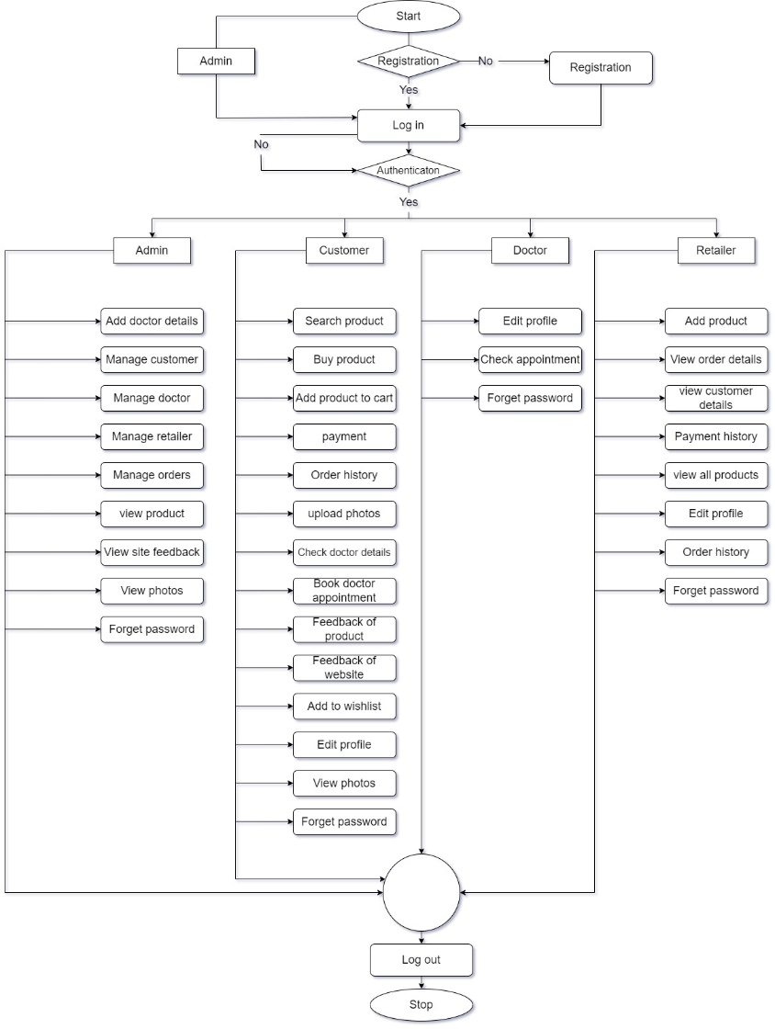

Data flow diagram:
The flow of data of a system or a process is represented by DFD. It also gives insight into the inputs and outputs of each entity and the process itself. Data Flow diagrams are very popular because they help us to visualize the major steps and data involved in software-system processes.

Context level 0.0

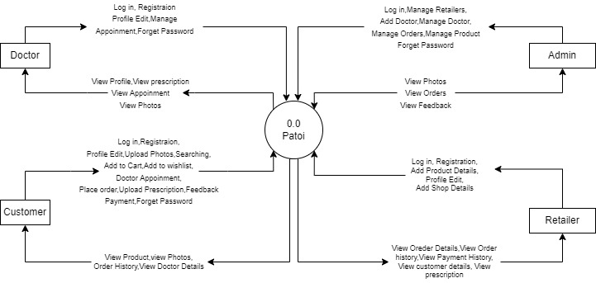

Customer level:

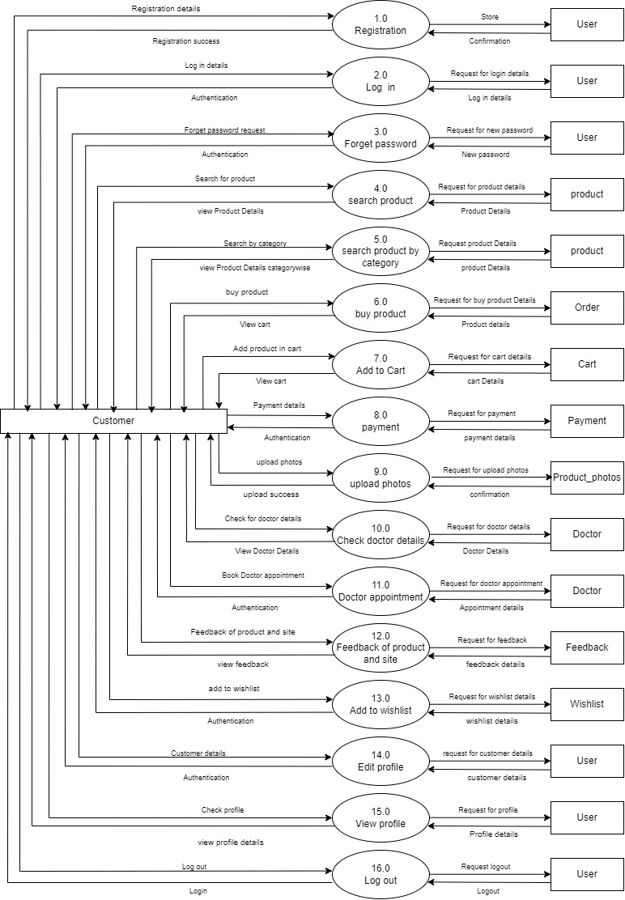

Retailer level:

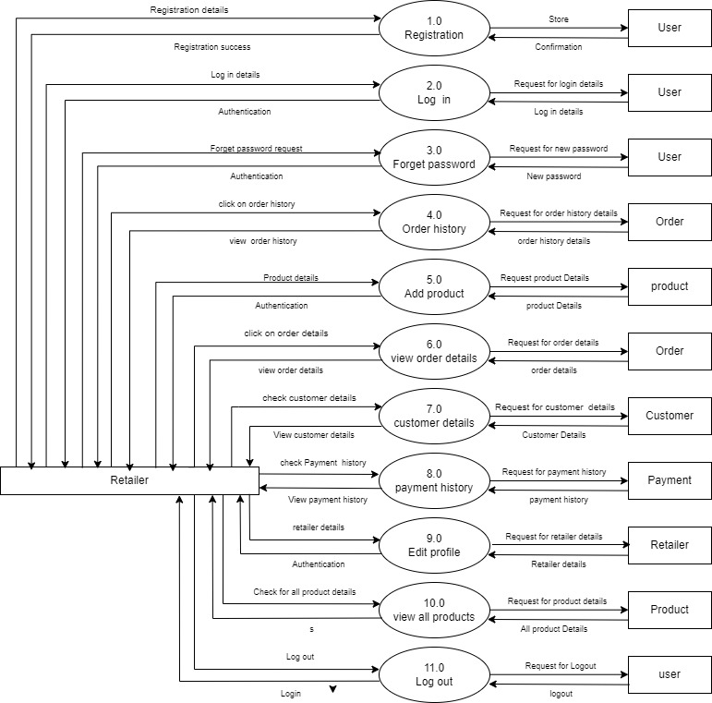

Doctor level:

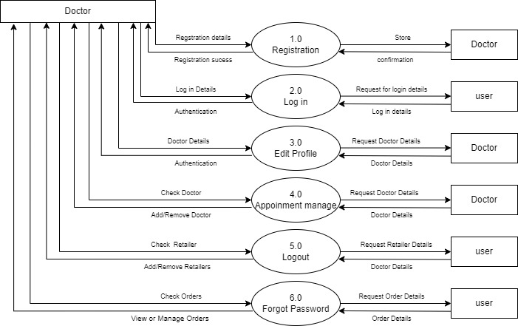

Admin level:

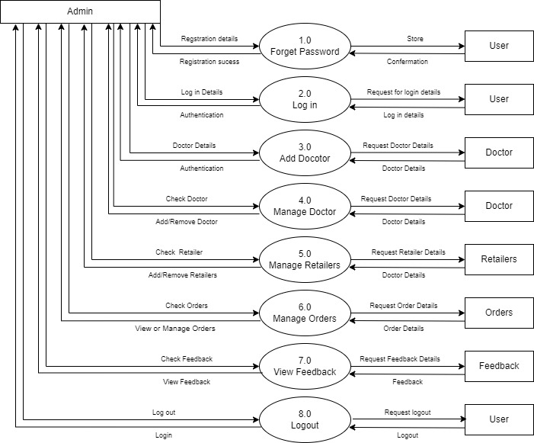

ER DIAGRAMME:
- ER Diagram stands for Entity Relationship Diagram, also known as ERD is a diagram that displays the relationship of entity sets stored in a database. In other words, ER diagrams help to explain the logical structure of databases. ER diagrams are created based on three basic concepts: entities, attributes and relationships.
- ER Diagrams contain different symbols that use rectangles to represent entities, ovals to define attributes and diamond shapes to represent relationships.

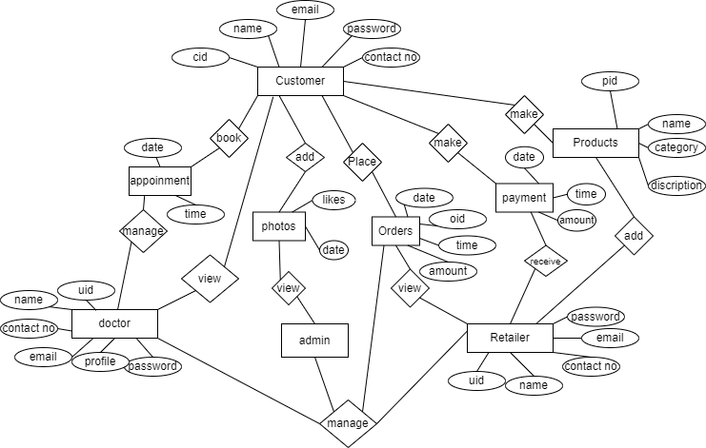

USE CASE:
- ADMIN
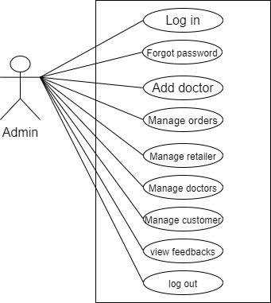

- DOCTOR:

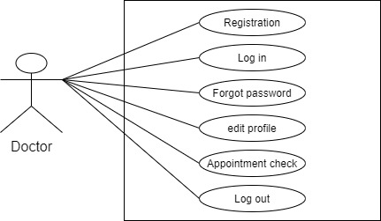

- CUSTOMER:

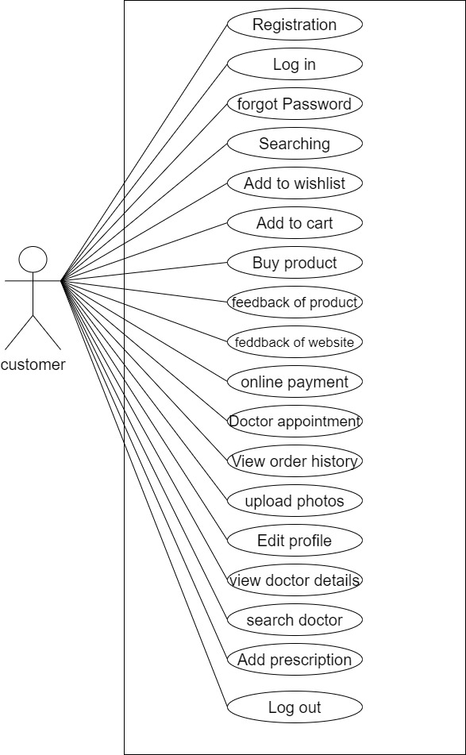

- RETAILER:

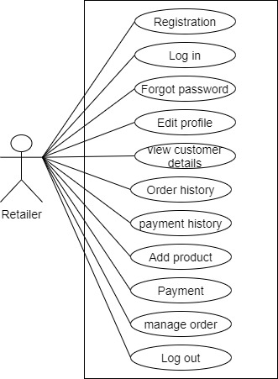

CHAPTER 9: Limitations and FUTURE ENHANCEMENT

Limitations:
- Customer can talk to the doctor through audio call only.
- Customer can not chat with doctor directly.
- Customer can not comment on posts.
- Customer can not download posts.

Future enhancement:
The project can be enhanced by including the live meeting session for customer who want to attend doctor from remote area then the can attend it. Customer can attend the doctor by video calling using app only. Customer can chat with doctor directly.

This project can be enhanced further by Developing a Mobile App. Also we can Develop a Full-Fledged accounting module. The software is flexible enough to be modified and implemented as per future requirements.
- Chat system
- Video-calling
- Comment on posts
- Download posts

CHAPTER 10: CONCLUSION

- The entire solution will provide a hassle free, user-friendly affordable commercial platform for buying food, accessories, breed of pet. It also provides medical platform for customers.
- over remaining features like viewing and posting photos, like photos. Feedbacks, doctor appointment will give customer very user-friendly platform.
- Our application is implemented to help customers by allow them connecting with doctors. It will allow the customers access information about doctors, and different products for pet. It also gives platform to the retailers to sell their products and increase business.
- This Web application PATOI to reduce the human efforts and errors to increase crystal clear transparency between customers and doctors. It also helps to reduce the time and efforts for manual communication.

